Basic Statistics Part 1

Q1) Identify the Data type for the following:
Activity | Data Type
Number of beatings from Wife | Discrete
Results of rolling a dice | Discrete
Weight of a person | Continuous
Weight of Gold | Continuous
Distance between two places | Continuous
Length of a leaf | Continuous
Dog's weight | Continuous
Blue Color | Discrete
Number of kids | Discrete
Number of tickets in Indian railways | Discrete
Number of times married | Discrete
Gender (Male or Female) | Discrete

Q2) Identify the Data types, which were among the following
Nominal, Ordinal, Interval, Ratio.
Data | Data Type
Gender | Nominal
High School Class Ranking | Ordinal
Celsius Temperature | Interval
Weight | Ratio
Hair Color | Nominal
Socioeconomic Status | Ordinal
Fahrenheit Temperature | Interval
Height | Ratio
Type of living accommodation | Nominal
Level of Agreement | Nominal
IQ(Intelligence Scale) | Interval
Sales Figures | Ratio
Blood Group | Nominal
Time Of Day | Ordinal
Time on a Clock with Hands | Interval
Number of Children | Ratio
Religious Preference | Nominal
Barometer Pressure | Interval
SAT Scores | Interval
Years of Education | Ratio

Q3) Three Coins are tossed, find the probability that two heads and one tail are obtained?
Answer-:
H = Head
T = tail
S{HHH, HHT, HTH, THH, TTH, THT, HTT, TTT}
N(S) = 8
P(A) = n(A)/n(S)
P(A) = 3/8 = 0.375

Q4) Two Dice are rolled, find the probability that sum is
- Equal to 1
- Less than or equal to 4
- Sum is divisible by 2 and 3
Answer-:
S{(1,1),(1,2),(1,3),(1,4),(1,5),(1,6),
(2,1),(2,2),(2,3),(2,4),(2,5),(2,6),
(3,1),(3,2),(3,3),(3,4),(3,5),(3,6),
(4,1),(4,2),(4,3),(4,4),(4,5),(4,6),
(5,1),(5,2),(5,3),(5,4),(5,5),(5,6),
(6,1),(6,2),(6,3),(6,4),(6,5),(6,6)}
n(S) = 36
- Equal to 1
Answer-:
Event sum of equal to 1 = 0
- Less than or equal to 4
Answer-:
B{(1,1),(1,2),(1,3),(2,1),(2,2),(3,1)}
n(B) = 6
P(B) = n(B)/ n(S)
P(B) = 6/36 = 0.1666666666666667
- Sum is divisible by 2 and 3
Answer-:
C{(1,6),(2,4),(3,3),(4,2),(5,1),(6,6)}
P(C) = n(C) /n(S)
P(C) = 6/36 = 0.1666666666666667

Q5) A bag contains 2 red, 3 green and 2 blue balls. Two balls are drawn at random. What is the probability that none of the balls drawn is blue?
Answer-:
Total number of balls
= (2 + 3 + 2)
= 7
Let S be the sample space
Then, n(S) = Number of ways of drawing 2 balls out of 7
n(S)=7C2
n(S)=(7×6)/(2×1)
n(S)=21
Let E = Event of 2 balls, none of which is blue
therefore n(E) = Number of ways of drawing 2 balls out of (2 + 3) balls
n(E)=5C2
n(E)=(5×4)/(2×1)
n(E)=10
P(E)=n(E)/n(S) = 10/21

Q6) Calculate the Expected number of candies for a randomly selected child
Below are the probabilities of count of candies for children (ignoring the nature of the child-Generalized view)
CHILD | Candies count | Probability
A | 1 | 0.015
B | 4 | 0.20
C | 3 | 0.65
D | 5 | 0.005
E | 6 | 0.01
F | 2 | 0.120
Child A – probability of having 1 candy = 0.015.
Child B – probability of having 4 candies = 0.20
Answer-:
The Expected number of candies for a randomly selected child
= 1*0.015+4*0.20+3*0.65+5*0.005+6*0.01+2*0.120
= 0.015+0.8+1.95+0.025+0.06+0.24
= 3.09
Q7) Calculate Mean, Median, Mode, Variance, Standard Deviation, Range & comment about the values / draw inferences, for the given dataset
-For Points,Score,Weigh>
Find Mean, Median, Mode, Variance, Standard Deviation, and Range and also Comment about the values/ Draw some inferences.
Answer:-
 | Points | Score | Weigh
Mazda RX4 | 3.9 | 2.62 | 16.46
Mazda RX4 Wag | 3.9 | 2.875 | 17.02
Datsun 710 | 3.85 | 2.32 | 18.61
Hornet 4 Drive | 3.08 | 3.215 | 19.44
Hornet Sportabout | 3.15 | 3.44 | 17.02
Valiant | 2.76 | 3.46 | 20.22
Duster 360 | 3.21 | 3.57 | 15.84
Merc 240D | 3.69 | 3.19 | 20
Merc 230 | 3.92 | 3.15 | 22.9
Merc 280 | 3.92 | 3.44 | 18.3
Merc 280C | 3.92 | 3.44 | 18.9
Merc 450SE | 3.07 | 4.07 | 17.4
Merc 450SL | 3.07 | 3.73 | 17.6
Merc 450SLC | 3.07 | 3.78 | 18
Cadillac Fleetwood | 2.93 | 5.25 | 17.98
Lincoln Continental | 3 | 5.424 | 17.82
Chrysler Imperial | 3.23 | 5.345 | 17.42
Fiat 128 | 4.08 | 2.2 | 19.47
Honda Civic | 4.93 | 1.615 | 18.52
Toyota Corolla | 4.22 | 1.835 | 19.9
Toyota Corona | 3.7 | 2.465 | 20.01
Dodge Challenger | 2.76 | 3.52 | 16.87
AMC Javelin | 3.15 | 3.435 | 17.3
Camaro Z28 | 3.73 | 3.84 | 15.41
Pontiac Firebird | 3.08 | 3.845 | 17.05
Fiat X1-9 | 4.08 | 1.935 | 18.9
Porsche 914-2 | 4.43 | 2.14 | 16.7
Lotus Europa | 3.77 | 1.513 | 16.9
Ford Pantera L | 4.22 | 3.17 | 14.5
Ferrari Dino | 3.62 | 2.77 | 15.5
Maserati Bora | 3.54 | 3.57 | 14.6
Volvo 142E | 4.11 | 2.78 | 18.6

 | Points | Score | Weigh
Mean | 3.597 | 3.217 | 17.85
Median | 3.695 | 3.325 | 17.71
Mode | numeric | numeric | numeric
Range | 2.76 4.93 | 1.513 5.424 | 14.5 22.9
Variance | 0.285881350806452 | 0.957378967741936 | 3.19316612903226
Standard deviation | 0.534678736070971 | 0.978457442989697 | 1.78694323609684

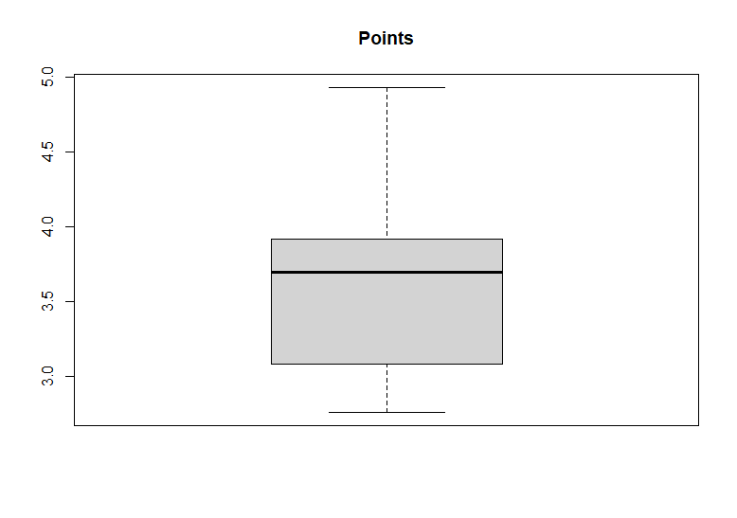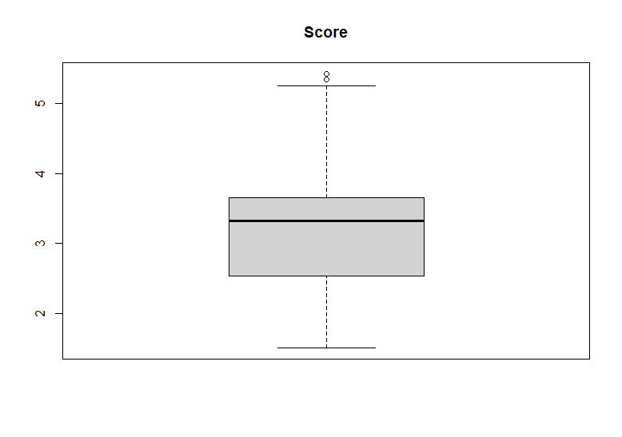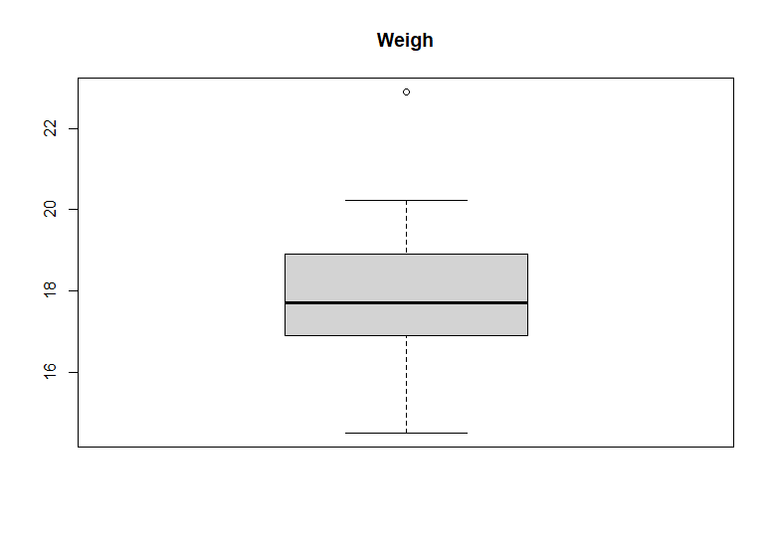
Code:-
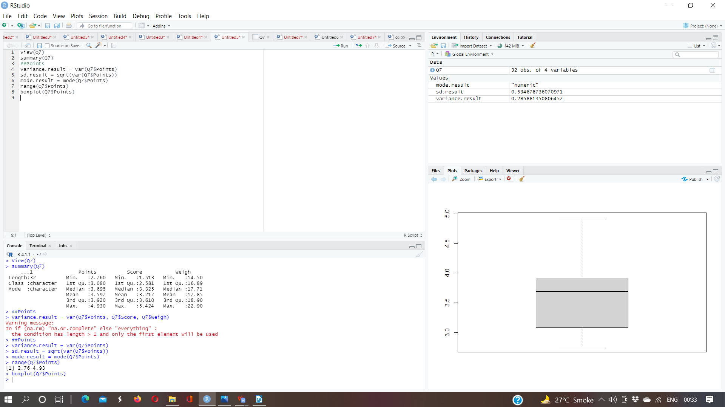
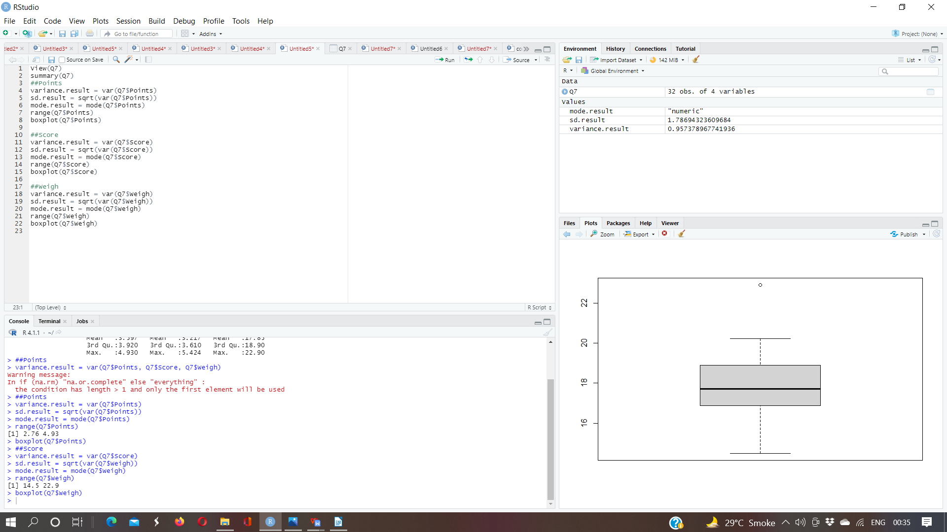
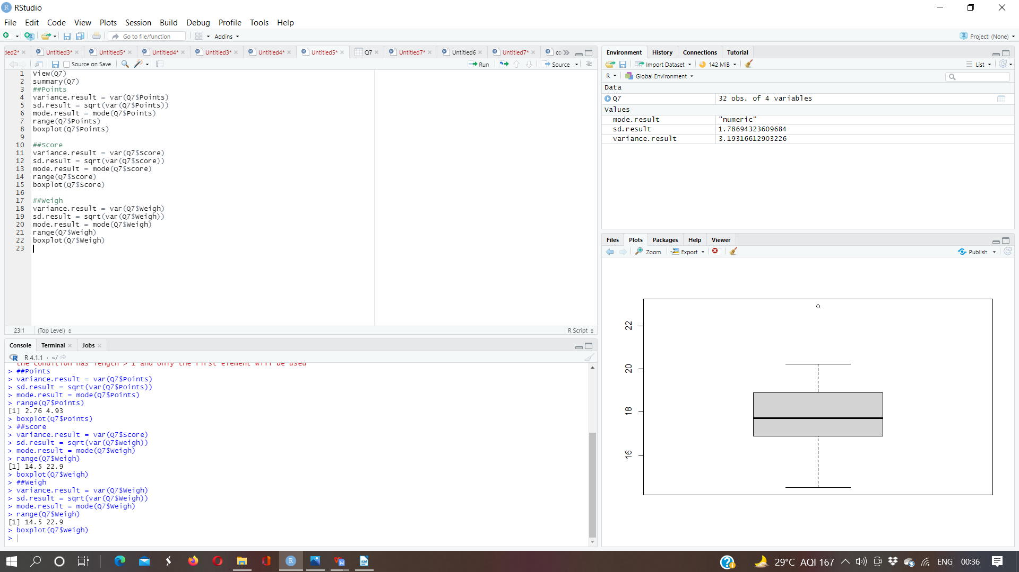
Q8) Calculate Expected Value for the problem below
- The weights (X) of patients at a clinic (in pounds), are
108, 110, 123, 134, 135, 145, 167, 187, 199
Assume one of the patients is chosen at random. What is the Expected Value of the Weight of that patient?
Answer:- Expected Value of X
S(108, 110, 123, 134, 135, 145, 167, 187, 199)
n(S) = 9
P(X) = n(X)/n(S)
P(X) = 1308/9
P(X) = 145.333333

Q9) Calculate Skewness, Kurtosis & draw inferences on the following data
Cars speed and distance
Use Q9_a.csv

SP and Weight(WT)
Use Q9_b.csv
Answer:-

- Car Speed and Distance
Index | speed | dist
1 | 4 | 2
2 | 4 | 10
3 | 7 | 4
4 | 7 | 22
5 | 8 | 16
6 | 9 | 10
7 | 10 | 18
8 | 10 | 26
9 | 10 | 34
10 | 11 | 17
11 | 11 | 28
12 | 12 | 14
13 | 12 | 20
14 | 12 | 24
15 | 12 | 28
16 | 13 | 26
17 | 13 | 34
18 | 13 | 34
19 | 13 | 46
20 | 14 | 26
21 | 14 | 36
22 | 14 | 60
23 | 14 | 80
24 | 15 | 20
25 | 15 | 26
26 | 15 | 54
27 | 16 | 32
28 | 16 | 40
29 | 17 | 32
30 | 17 | 40
31 | 17 | 50
32 | 18 | 42
33 | 18 | 56
34 | 18 | 76
35 | 18 | 84
36 | 19 | 36
37 | 19 | 46
38 | 19 | 68
39 | 20 | 32
40 | 20 | 48
41 | 20 | 52
42 | 20 | 56
43 | 20 | 64
44 | 22 | 66
45 | 23 | 54
46 | 24 | 70
47 | 24 | 92
48 | 24 | 93
49 | 24 | 120
50 | 25 | 85

 | skewness | kurtosis
Speed | -0.1139548 | 2.422853
Distance | 0.7824835 | 3.248019

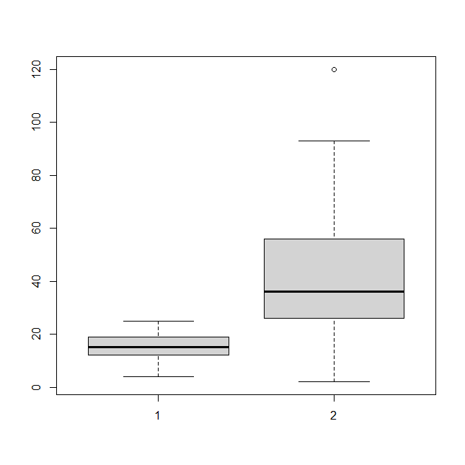
Code:-
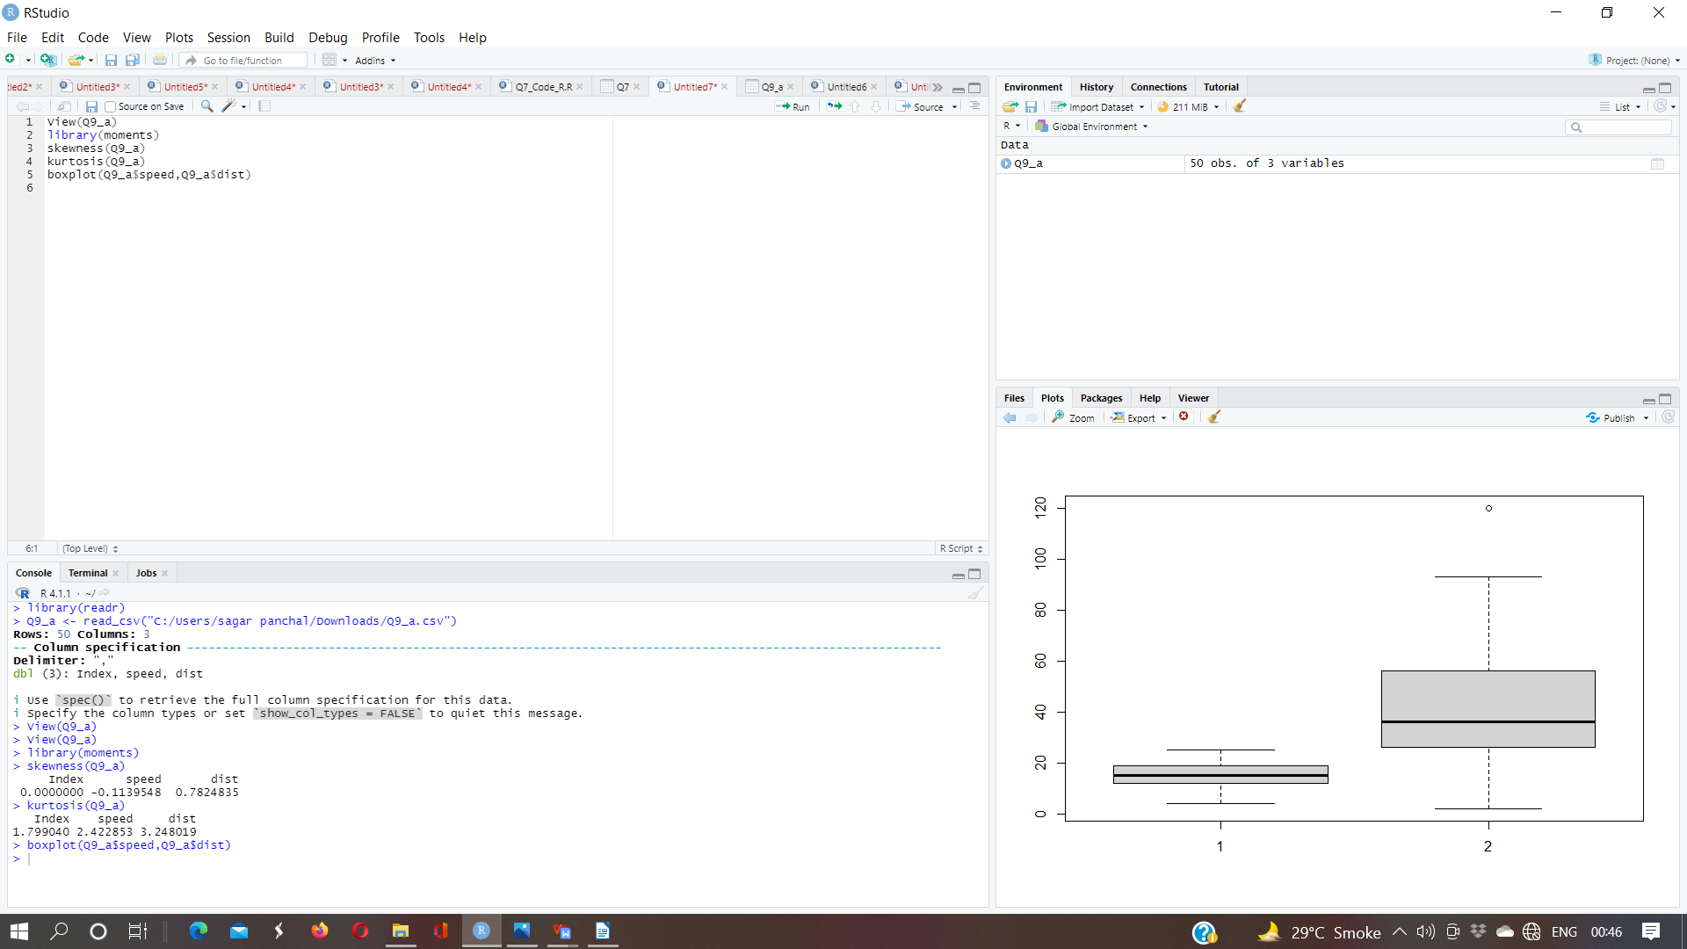
- SP and Weight
 | SP | WT
1 | 104.1853528 | 28.7620589
2 | 105.4612635 | 30.46683298
3 | 105.4612635 | 30.19359657
4 | 113.4612635 | 30.63211391
5 | 104.4612635 | 29.88914864
6 | 113.1853528 | 29.59176832
7 | 105.4612635 | 30.30847957
8 | 102.5985128 | 15.84775807
9 | 102.5985128 | 16.35948352
10 | 115.6452041 | 30.92015417
11 | 111.1853528 | 29.36334142
12 | 117.5985128 | 15.75353468
13 | 122.1050553 | 32.81359241
14 | 111.1853528 | 29.3784363
15 | 108.1853528 | 29.34727902
16 | 111.1853528 | 29.60452658
17 | 114.3692933 | 29.5357836
18 | 117.5985128 | 16.19412154
19 | 114.3692933 | 29.92939368
20 | 118.4729364 | 33.51697417
21 | 119.1050553 | 32.32464971
22 | 110.8408174 | 34.90821127
23 | 120.2889958 | 32.6758277
24 | 113.8291446 | 31.83712236
25 | 119.1853528 | 28.78172789
26 | 114.5985128 | 16.04317492
27 | 120.7605199 | 38.06282335
28 | 119.1050553 | 32.83506939
29 | 99.56490661 | 34.4832075
30 | 121.8408174 | 35.54935984
31 | 113.4846092 | 37.04235003
32 | 112.2889958 | 33.23436141
33 | 119.9211148 | 31.38004084
34 | 121.3926389 | 37.57328965
35 | 111.2889958 | 32.701644
36 | 115.0130851 | 31.9112234
37 | 114.0933825 | 28.75400008
38 | 116.909442 | 27.87991549
39 | 116.909442 | 28.63050247
40 | 128.4612635 | 30.11543403
41 | 116.3926389 | 37.39252442
42 | 115.7488471 | 35.02717556
43 | 117.4612635 | 30.52742698
44 | 114.0933825 | 28.34397592
45 | 114.3809661 | 33.07863163
46 | 117.1050553 | 32.62191589
47 | 118.2086984 | 36.49861738
48 | 116.4729364 | 33.91005598
49 | 127.909442 | 28.07059654
50 | 118.2889958 | 33.45847152
51 | 118.2889958 | 33.21395395
52 | 118.2889958 | 33.43671117
53 | 120.4043117 | 40.39816357
54 | 143.3926389 | 37.62069475
55 | 135.3926389 | 37.25439197
56 | 126.4043117 | 40.58906845
57 | 110.4612635 | 30.14754329
58 | 118.2889958 | 32.73451818
59 | 112.6452041 | 30.61528334
60 | 115.5765794 | 37.66287367
61 | 130.2086984 | 36.88815313
62 | 117.6685497 | 37.86041143
63 | 126.0481035 | 43.3909885
64 | 125.3123415 | 40.72283115
65 | 128.128401 | 40.15948186
66 | 126.5985128 | 15.71285853
67 | 132.4846092 | 37.97995604
68 | 133.6802225 | 41.57397476
69 | 133.3123415 | 40.47204238
70 | 158.3006687 | 37.14173328
71 | 164.5985128 | 15.82306042
72 | 133.4159845 | 44.01313857
73 | 133.1400738 | 43.35312292
74 | 124.7152409 | 52.99775236
75 | 121.864163 | 42.61869847
76 | 132.864163 | 42.77821864
77 | 169.5985128 | 16.13294744
78 | 150.5765794 | 37.92311321
79 | 151.5985128 | 15.76962542
80 | 167.9444604 | 39.42309899
81 | 139.8408174 | 34.94861469

 | skewness | kurtosis
SP | 1.581454 | 5.723521
Weight | -0.6033099 | 3.819466

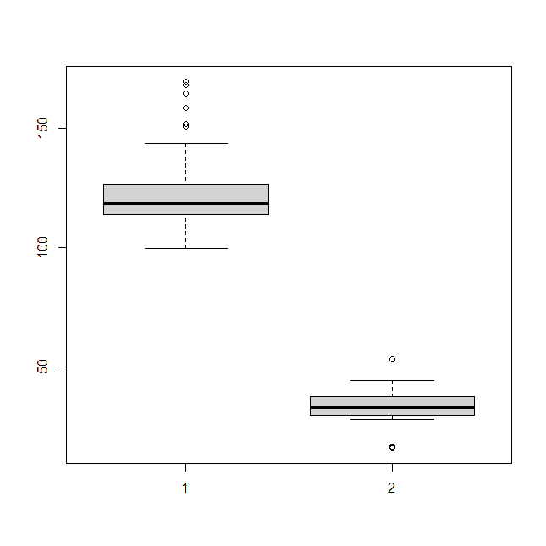
Code:-
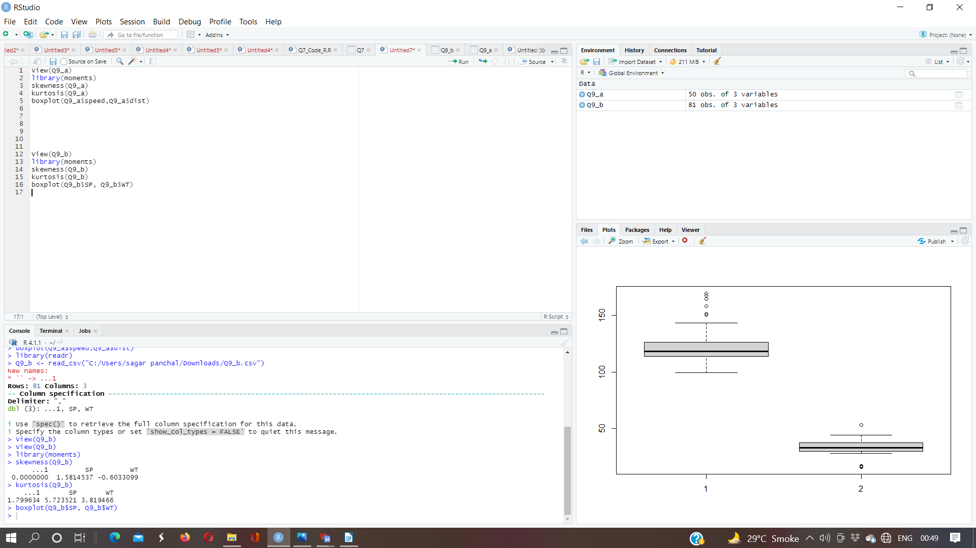

Q10) Draw inferences about the following boxplot & histogram
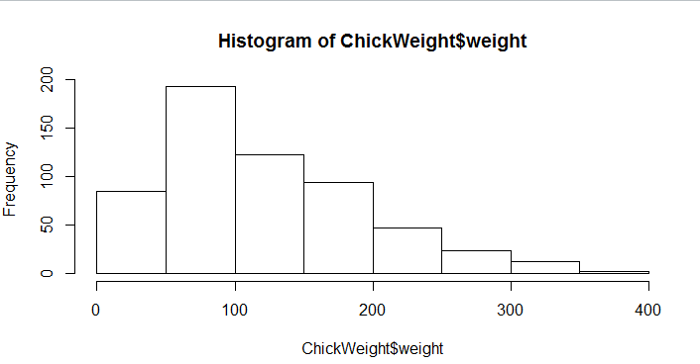

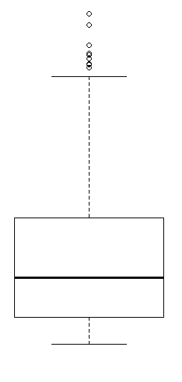

Answer:-
10.a
(1) The distribution of data is right skewed or positive skewed and most of the data lie on the right side
(2) Majority of chick are having weight less than 200
(3) The most of the data points are connected in the range 50-100 and lest range in 0-10 are in 400
(4) The man in the case of distribution will be greater than the median
10.b
- The above boxplot we can see that are outliers beyond the upper extreme.
- The boxplot is skewed right and most of the data is concentrade in the lower quartike
Q11) Suppose we want to estimate the average weight of an adult male in Mexico. We draw a random sample of 2,000 men from a population of 3,000,000 men and weigh them. We find that the average person in our sample weighs 200 pounds, and the standard deviation of the sample is 30 pounds. Calculate 94%,98%,96% confidence interval?
Answer:-
X+/-(Z1- α. σ/sqrt(n)
Degrees of freedom= 2000-1= 1999
Confidence interval= 94%
(1- σ/2)= 1-0.03) =0.97
for confidene interval for 94% is 1.882
Confidence interval for 98%= 2.33
Confidence interval for 96% = 2.05

Q12) Below are the scores obtained by a student in tests
34,36,36,38,38,39,39,40,40,41,41,41,41,42,42,45,49,56
- Find mean, median, variance, standard deviation.
- What can we say about the student marks?
Answer:-
(1)
mean | 41.00
median | 40.50
variance | 25.5294117647059
Standard deviation | 5.05266382858645

- The average marks obtained by student in test is 41 and we can say that student is maintaining his/her marks around 41 as deviation is very less

Q13) What is the nature of skewness when mean, median of data are equal?
Answer:- symmetrical distribution

Q14) What is the nature of skewness when mean > median ?
Answer:- Right skewed distribution

Q15) What is the nature of skewness when median > mean?
Answer:- Left Skewed

Q16) What does positive kurtosis value indicates for a data ?
Answer:- A distribution with a positive kurtosis value indicates that the distribution has heavier tails than the normal distribution.

Q17) What does negative kurtosis value indicates for a data?
Answer:- A distribution with a negative kurtosis value indicates that the distribution has lighter tails than the normal distribution.

Q18) Answer the below questions using the below boxplot visualization.
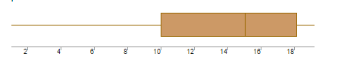
- What can we say about the distribution of the data?
- What is nature of skewness of the data?
- What will be the IQR of the data (approximately)?
Answer:-
(a) We can say that the distribution of data is not symmetrical. In other words, most of the data lies on the right side or in the upper quartile.
(b) Nature: Data is left skewed or negative skewed.
(c) Approximately= IQR = Q3-Q1
=18-10
=8
Q19) Comment on the below Boxplot visualizations?
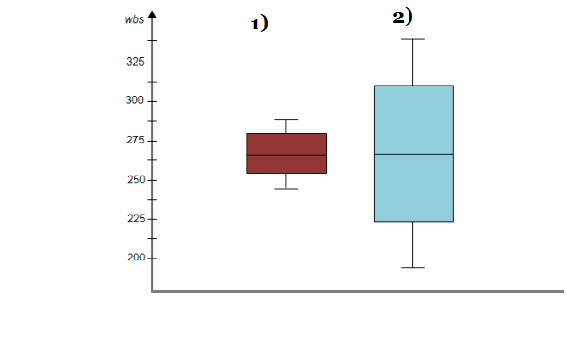
Draw an Inference from the distribution of data for Boxplot 1 with respect Boxplot 2.
Answer:-
- Both the boxplot have uniform distribution and same median.
- The IQR for boxplot 1 is lower than the IQR for boxplot 2. Hence, the data points in boxplot 1 are consistenly hovered around the central value than in boxplot 2.
- The range of data of boxplot 1 smaller than the range of data of boxplot 2. Hence, the overall data is widely distributed in boxplot 2 as compared to boxplot 1.
- There are no outliers present in both the boxplot.
Q 20) Calculate probability from the given dataset for the below cases

Data _set: Cars.csv
Calculate the probability of MPG of Cars for the below cases.
MPG <- Cars$MPG
  - P(MPG>38)
  - P(MPG<40)
  - P (20<MPG<50)
Answer:-
- There are 33 observations in MPG which are greater then 38.
- There are 61 observations in MPG which are lesser then 40.
- There are 69 observations in MPG which are lgreater then 20 & there are 81 observations in MPG which lesser then 50. (69/81)
Code:-
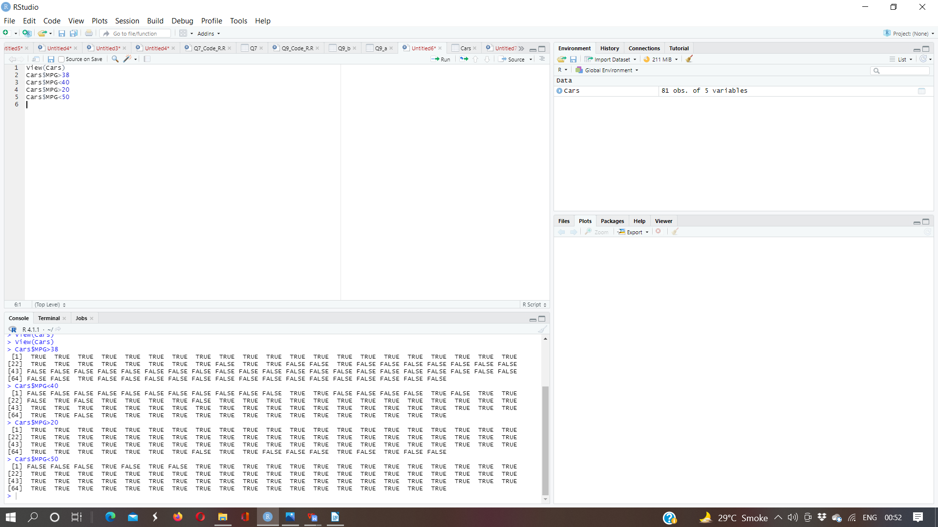

Q 21) Check whether the data follows normal distribution
- Check whether the MPG of Cars follows Normal Distribution
Dataset: Cars.csv
- Check Whether the Adipose Tissue (AT) and Waist Circumference(Waist) from wc-at data set follows Normal Distribution
Dataset: wc-at.csv
Answer:-
- We can interpret that the data of weight of MPG of cars follows the normal distribution by:
- Conducting shapiro test(W = 0.98846, p-value = 0.6872)
- Evaluating kurtosis value which is 2.352262 & skewness value ehich is -0.1746343
- Finding of mean value (34.42) which is not so far difference from meadian value (35.15 )

- .(A) We can interpret that the data of waist of WC_AT of cars follows the normal distribution by:
(1 ) Conducting shapiro test(W = 0.99119, p-value = 0.7087)
(2) Evaluating kurtosis value which is 1.892724 & skewness value ehich 0.1322042
(3) Finding of mean value (91.9) which is not so far difference from meadian value ( 90.8)

b) .(B) We can interpret that the data of AT of WC_AT of cars follows the normal distribution by:
(1) Conducting shapiro test(W = 0.99352, p-value = 0.891)
(2) Evaluating kurtosis value which is 2.672812 & skewness value ehich is 0.5767897
(3) Finding of mean value (101.89) which is not so far difference from meadian value (96.54)

Code:-
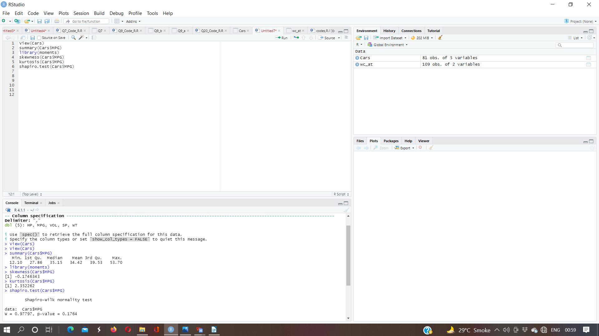

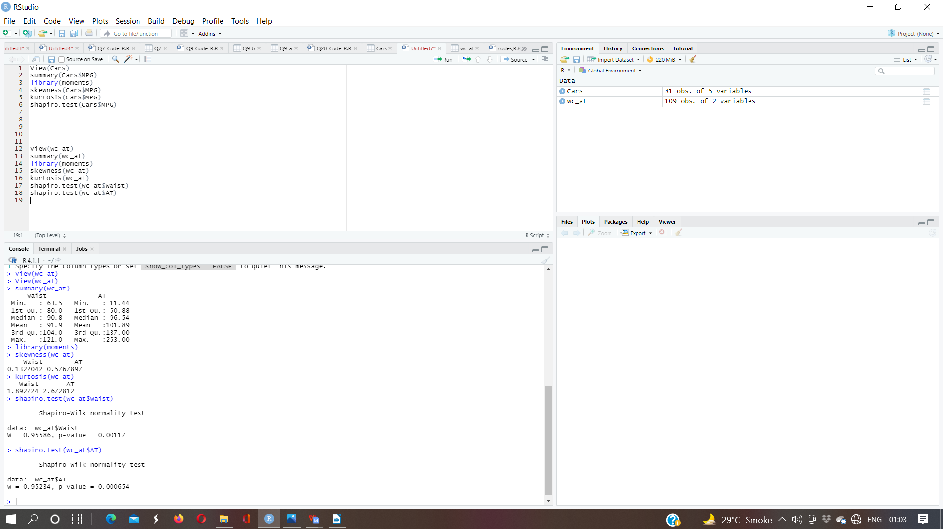

Q 22) Calculate the Z scores of 90% confidence interval,94% confidence interval, 60% confidence interval
Answer:-
Z score of 90% confidence interval is 1.644854
Z score of 94% confidence interval is 1.880794
Z score of 60% confidence interval is 0.8416212

Q 23) Calculate the t scores of 95% confidence interval, 96% confidence interval, 99% confidence interval for sample size of 25
Answer:-
t scores of 95% confidence interval is 1.959964
t scores of 96% confidence interval is 2.053749
t scores of 25% confidence interval is 0.3186394

Q 24) A Government company claims that an average light bulb lasts 270 days. A researcher randomly selects 18 bulbs for testing. The sampled bulbs last an average of 260 days, with a standard deviation of 90 days. If the CEO's claim were true, what is the probability that 18 randomly selected bulbs would have an average life of no more than 260 days
Hint:
rcode → pt(tscore,df)
df → degrees of freedom
Answer:-
Mean = 270 days = u
Sample size = 18 = n
Smaple mean = 260 = x
Deviation sample = 90 days =s
Sol:-
t = 260-270/90/sqrt18
t = -10/90/3^2
t = -10/30/2^
t = -1*2^/3
t = 0.417

